**Comedian’s Cafe Town**

System Design

**Functional Requirements:**

* Daily email distribution to all users.
* Users must be able to vote for their preferred comedians.
* Comedians must receive their voting scores on a weekly basis.
* Automated enrollment for users in the next month's subscription for the content of a voted comedian that ranks in the top 20.
* Daily analytics run to identify the top 20 comedians and 5 random comedians of the day.
* Weekly score updates for the selected comedians during the week.
* Capturing and extraction of comedians' replies to the weekly email and distribution to all subscribed users of that comedian.

**Non-Functional Requirements:**

* Performance
* Reliability

**High Level Design(HLD):**

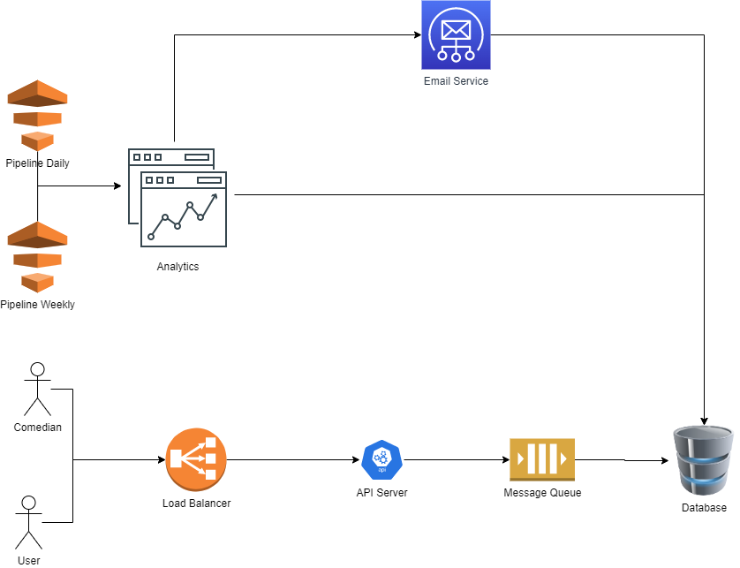

* Actors: End-users who can interact with the system
  + User
  + Comedian
* Load Balancer: Controls the flow of traffic between the end-users and API Server
* API Server: Handles the requests received from the end-users. Eg: Votes of comedian through email
* Message Queue: Converts the concurrent data into sequential by controlling flow of data from producer(end-user) to consumer(DB)
* Pipeline: A service that act as trigger
  + Daily
  + Weekly
* Analytics: Provides the daily analysis of most voted comedians, and weekly updates on scores.
* Email Service: Responsible for sending the emails to both users and comedians.

**Low Level Design(HLD):**

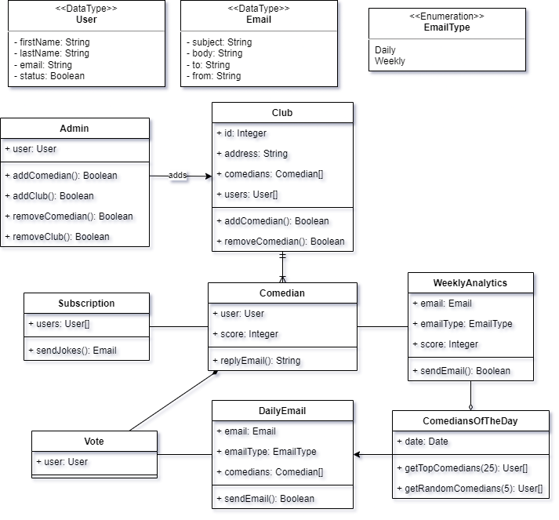

* **Admin Class:** This class is responsible for managing administrative tasks, such as adding new clubs or branches to the system.
* **Club Class:** This class manages all the activities that take place at a branch. Only an admin can add or remove clubs.
* **Comedian Class:** This class manages all activities related to individual comedians. There can be multiple comedians associated with each club, creating a one-to-many relationship.
* **Vote Class:** This class stores information related to users' votes for comedians.
* **DailyEmail Class:** This class is responsible for sending daily emails to all users.
* **ComediansOfTheDay Class:** This class has two methods - getTopComedians and getRandomComedians. The getTopComedians method selects the top 20 comedians based on user votes from the previous day, while the getRandomComedians method selects 5 comedians randomly.
* **WeeklyAnalytics Class:** This class is only created if a comedian is selected in the daily list of comedians. It holds information related to the weekly analytics for the selected comedians.
* **Subscription Class:** This class stores information about users who are subscribed to a comedian for the current month, based on their votes from the previous month.